**SPH3U 9.3 Beats**

1. **Beats**

|  |  |
| --- | --- |
| Beat: |  |
| Beat frequency: |  |
| equation |  |

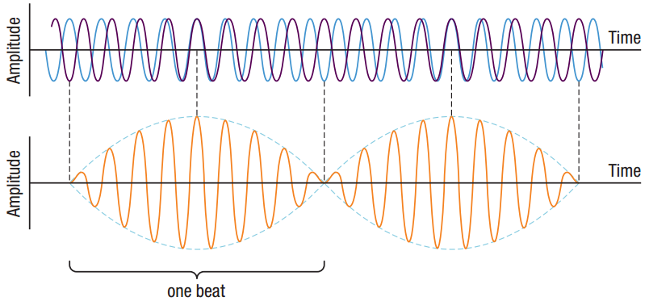

John is tuning his guitar. His string produces a frequency of 442 Hz, and his tuner produces a frequency of 440 Hz. What beat frequency does John hear?

**Homework:** page 429: #2-3